**Sreenidhi Institute of Science and Technology**

(Autonomous)

Yamnampet(V), Ghatkesar(M), Hyderabad – 501 301 | Telangana

**Department of Computer Science and Engineering**

**Computer Networks Assignment Project**

9EC05

*Simulating Network Topologies*

Bachelor of Technology in

**Computer Science and Engineering**

**2022-2026**

**Submitted by**

|  |  |
| --- | --- |
| J.Siri Sathvika | 22311A0514 |
| S.Chiranjita | 22311A0524 |
| Anjali Rao Dodla | 22311A0525 |
| A.Srilaya | 22311A0531 |

Under the Guidance of

**Dr. Aruna Varanasi**

**Head of the Department – CSE**

**ACKNOWLEDGEMENT**

I would like to express my gratitude to all the people behind the screen who helped me to transform an idea into a real application.

I would like to thank my Project coordinator Dr. ARUNA VARANASI for her technical guidance, constant encouragement and support in carrying out my project at college.

I would like to express my heart-felt gratitude to my parents without whom I would not have been privileged to achieve and fulfil my dreams. I am grateful to our principal, Dr. T. Ch. Siva Reddy, who most ably run the institution and has had the major hand in enabling me to do my project.

The satisfaction and euphoria that accompany the successful completion of the task would be great but incomplete without the mention of the people who made it possible with their constant guidance and encouragement crowns all the efforts with success. In this context, I would like thank all the other staff members, both teaching and non-teaching, who have extended their timely help and eased my task.

J SIRI SATHVIKA 22311A0514

S CHIRANJITA 22311A0524

D ANJALI RAO 22311A0525A

SRILAYA 22311A0531

**ABSTRACT**

This paper presents a comprehensive exploration of network topology simulation using Cisco Packet Tracer. The study delves into the design, configuration, and troubleshooting of various network topologies, including bus, star, mesh, ring, and hybrid. By utilizing Cisco Packet Tracer, a robust network simulation tool, we aim to provide a practical and hands-on approach to understanding network concepts and their real-world applications.

Through a series of simulations, we investigate the advantages, disadvantages, and performance characteristics of each topology. We explore the impact of factors such as device failures, link outages, and traffic congestion on network performance and reliability. Additionally, we examine the role of routing protocols, such as RIP and OSPF, in optimizing network traffic flow and ensuring efficient communication between devices.

The findings of this study offer valuable insights for network engineers, students, and researchers alike. By providing a solid foundation in network topology design and simulation, this research contributes to the advancement of network engineering practices and the development of innovative network solutions.

**TABLE OF CONTENTS**

Chapter no Title Page no

Abstract 3

Table of Contents 4

1 Introduction 5

2 Bus Topology 7 3 Ring Topology 8

4 Star Topology 9

5 Question 9

6 Output Screens 10-19

7 Applications and Scope 20

8 Conclusion 21

9 Bibilography 22

**INTRODUCTION**

**What is Network Topology?**

Network topology refers to the arrangement of devices and connections within a network. It defines how these components are interconnected and how data flows between them.

**Why Network Topologies?**

**Performance:**

* **Optimized Data Transfer Speeds**: Well-designed topologies can maximize data throughput.
* **Minimized Latency:** Efficient data routing reduces delays in communication.

**Reliability:**

* **Fault Tolerance:** Redundant connections can mitigate the impact of device failures.
* **Reduced Downtime**: Effective network design minimizes disruptions.

**Scalability:**

* **Easy Addition of New Devices:** Flexible topologies accommodate growth without major disruptions.
* **Flexible Network Expansion:** The ability to adapt to changing needs is crucial.

**Cost-Effectiveness:**

* **Reduced Cabling and Hardware Costs:** Efficient topology design can minimize infrastructure expenses.

**Manageability:**

* **Simplified Troubleshooting:** Well-structured networks are easier to diagnose and repair.
* **Efficient Upgrades:** Planned topology changes facilitate smooth network evolution.

**Common Network Topologies:**

1.Bus Topology

2.Ring Topology

3.Star Topology

4.Mesh Topology

5.Tree Topology

**Choosing the Right Topology:**

The optimal topology depends on several factors, including:

* **Network Size and Complexity:** Larger networks may require more complex topologies.
* **Performance Requirements:** High-performance applications demand efficient data transfer.
* **Reliability and Fault Tolerance:** Critical networks may prioritize redundancy.
* **Scalability:** Future growth should be considered.
* **Cost Constraints:** Budgetary limitations may influence topology choices.
* **Security Needs:** Sensitive data may require specific security measures.

By carefully considering these factors, network administrators can select the most appropriate topology to meet the specific needs of their organization. By understanding these topologies, network administrators can design and manage networks effectively, ensuring optimal performance, reliability, and scalability.

**Key concepts of Network Topologies:**

**1. Bus Topology:**

Bus topology is a type of network setup where all devices (computers, printers, etc.) are connected to a single cable, often called the "backbone" or "bus". Data travels along this cable to reach its destination.

**Key Characteristics**

* **Simple Structure:** Easy to set up and understand.
* **Cost-Effective:** Requires less cable than other topologies.
* **Scalable:** Can be easily expanded by adding more devices to the bus.
* **Half-Duplex:** Only one device can transmit data at a time.

**Advantages**

* **Easy Installation:** Simple wiring compared to other topologies.
* **Cost-Effective:** Requires less cable.
* **Scalable:** Easily expand by adding more devices.

**Disadvantages**

* **Single Point of Failure:** If the main cable fails, the entire network goes down.
* **Performance Bottlenecks:** Can become slow with heavy traffic.
* **Limited Distance:** Cable length is limited, affecting the size of the network.
* **Security Concerns:** Data is broadcast to all devices, raising security risks.

**Common Uses**

* **Small Networks:** Often used in homes or small offices with a few devices.
* **Legacy Systems:** Older networks may still use bus topology.

**2. Ring Topology:**

In a ring topology, devices are connected in a circular fashion.

Data travels in one direction around the ring until it reaches its destination.

**Key Characteristics:**

* **Circular Structure:** Devices are connected in a loop.
* **Data Flow:** Data travels in a specific direction around the ring.
* **Token Passing:** A special token is passed around the ring to control data transmission. Only the device holding the token can transmit data.

**Advantages:**

* **Efficient Data Transfer:** Data flows smoothly without collisions.
* **Easy Expansion:** New devices can be added without affecting the existing network.
* **Reliable:** Fault tolerance can be achieved through dual-ring configurations.

**Disadvantages:**

* **Single Point of Failure:** A break in the ring can disrupt the entire network.
* **Complex Installation:** More complex to set up than bus or star topologies.
* **Slower Performance:** Token passing can introduce latency.

**Common Uses:**

* Local Area Networks (LANs)
* Fiber Optic Networks

**3. Star Topology:**

In a star topology, all devices are connected to a central hub. This hub acts as a central point for all communication between devices.

**Key Characteristics:**

* **Central Hub:** All devices are connected to a central hub**.**
* **Point-to-Point Connections:** Each device has a dedicated connection to the hub.

**Advantages:**

* **Easy Installation:** Simple to set up and manage.
* **Reliable:** If one device fails, it doesn't affect the entire network**.**
* **Scalable:** Easy to add or remove devices.
* **Efficient Troubleshooting:** Issues can be easily isolated and fixed.

**Disadvantages:**

* **Single Point of Failure:** If the central hub fails, the entire network goes down.
* **Costly:** Requires more cable than bus topology.

**Common Uses:**

* Local Area Networks (LANs)
* Home Networks
* Small Office Networks

**QUESTION**

**Simulate the various topologies Bus, Ring & Star by connecting computers to network and assign class c IP address for each system.**

**1.BUS TOPOLOGY:**

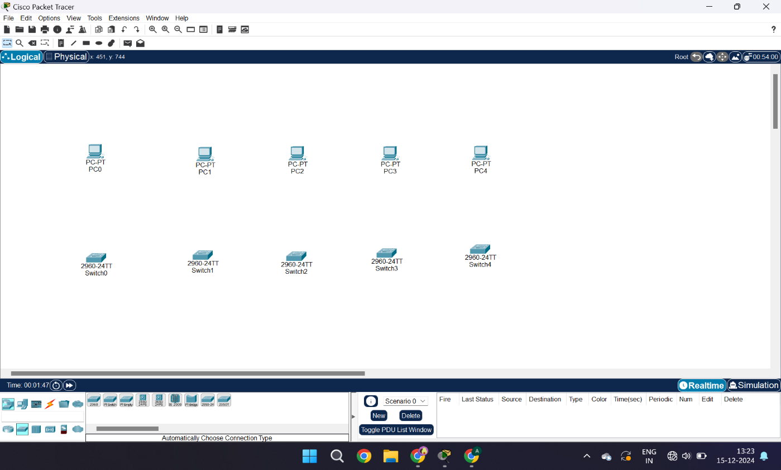

**Fig-1: Setting up PCs and Switches.**

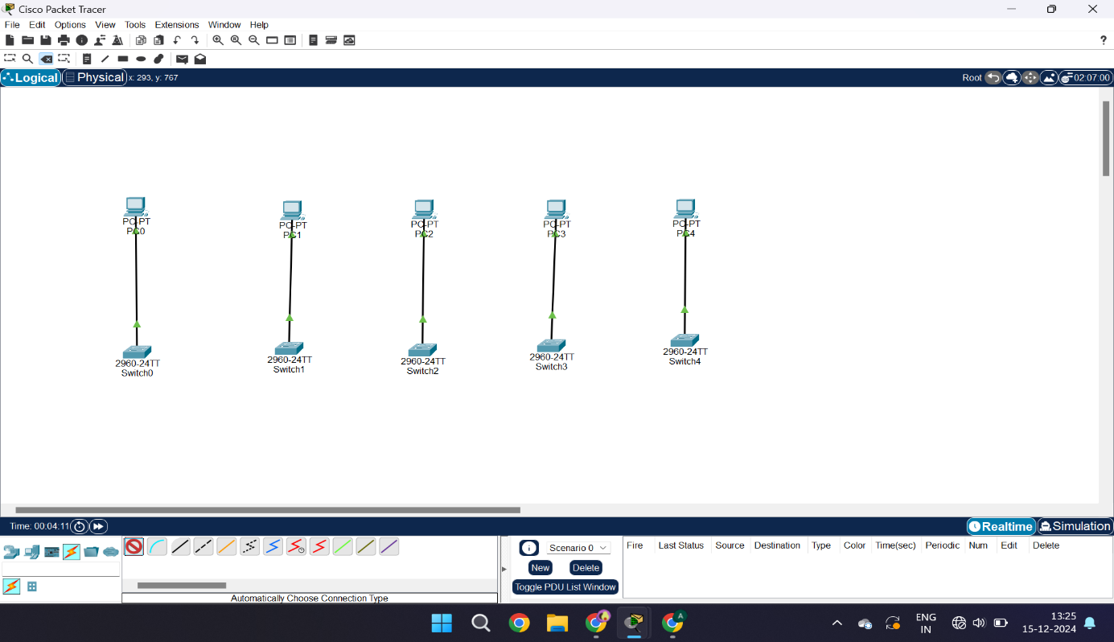**Fig-1.1: Connecting Switches to the PCs.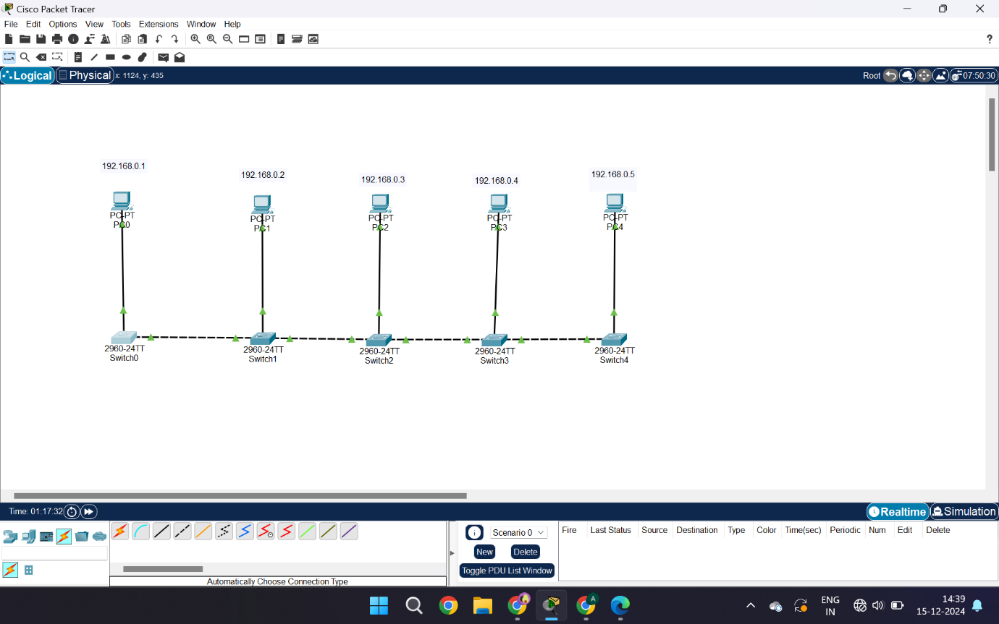 Fig-1.2: Connecting all the switches and assigning the IP address.**

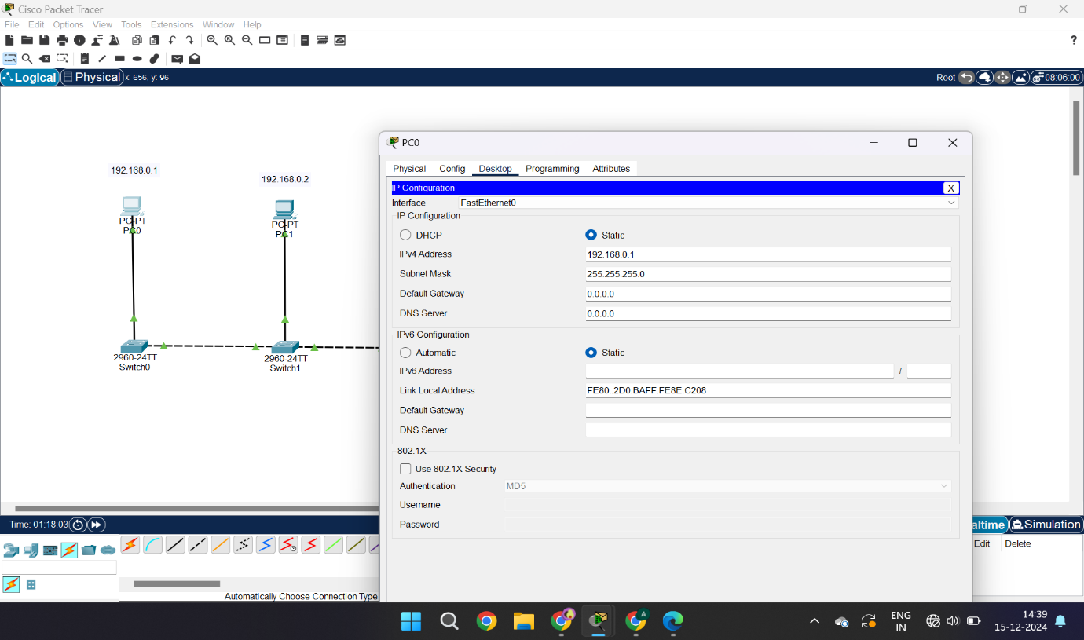

**Fig-1.3: Giving PCs their IPv4 address.**

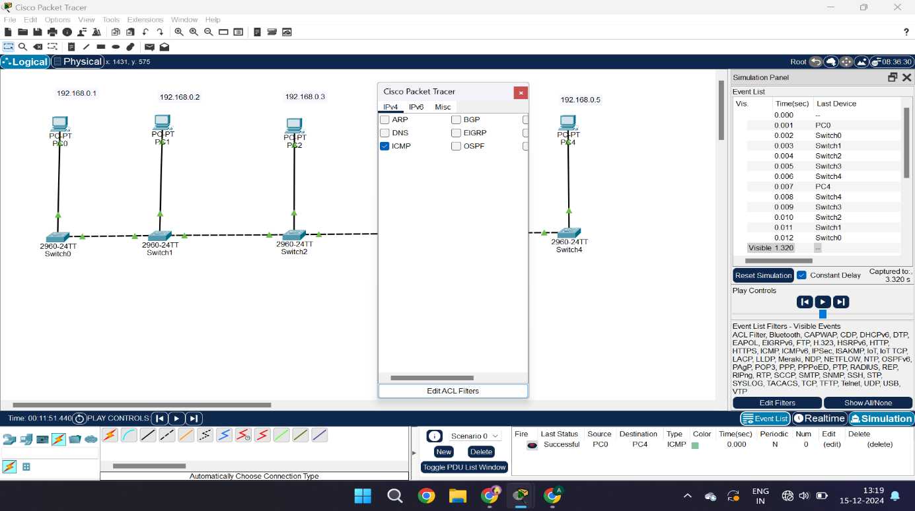

**Fig-1.4: Start the Simulation, chose ICMP mode.**

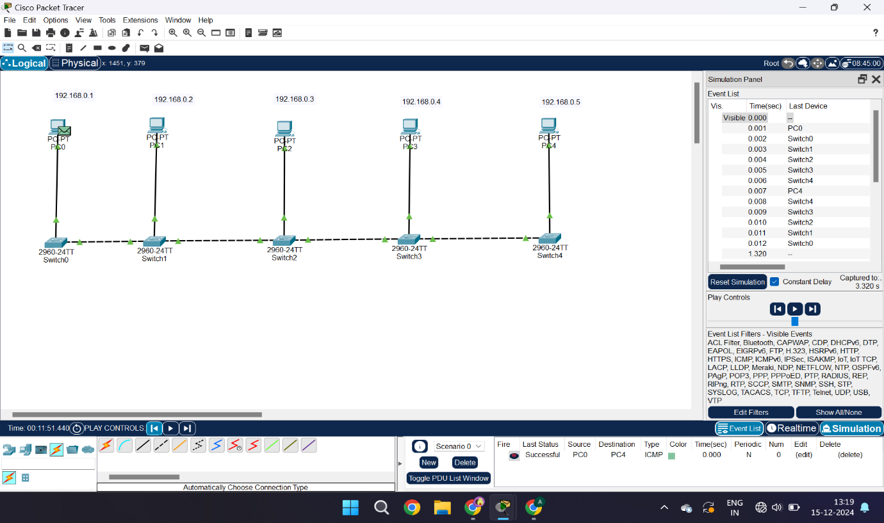**Fig-1.5: Sending the packet from PC1(Source) to PC5(Destination).**

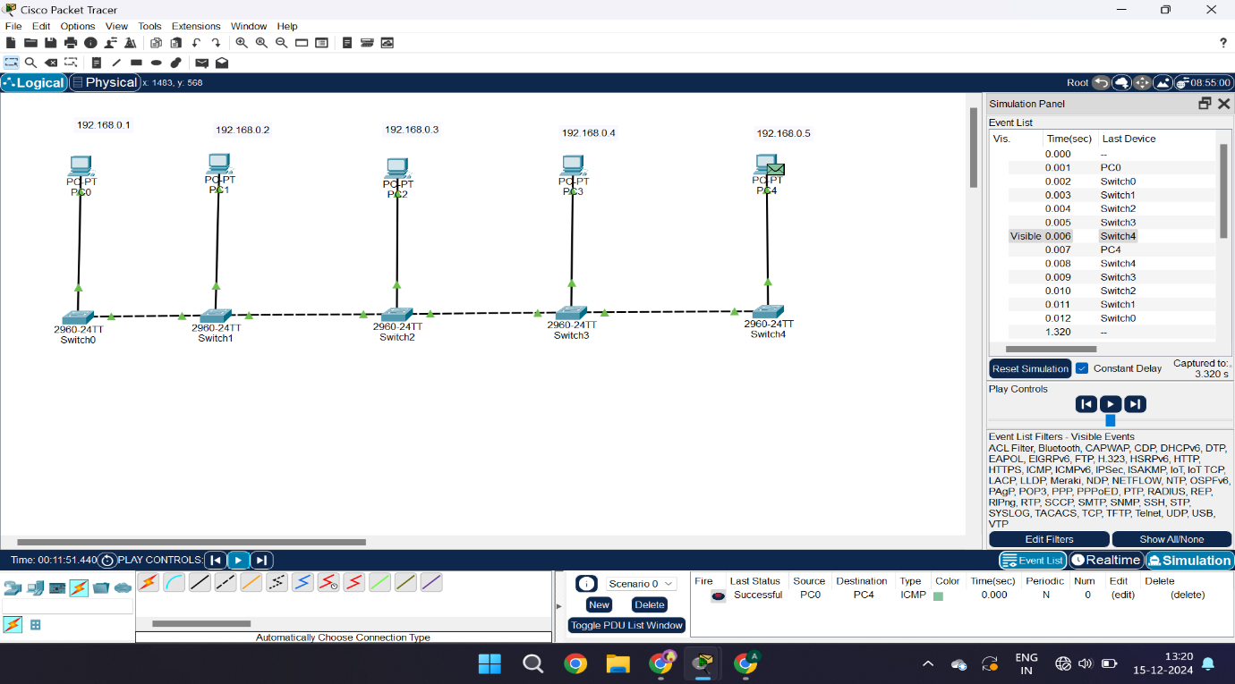**Fig-1.6: Packet at Destination. Acknowledgement received.**

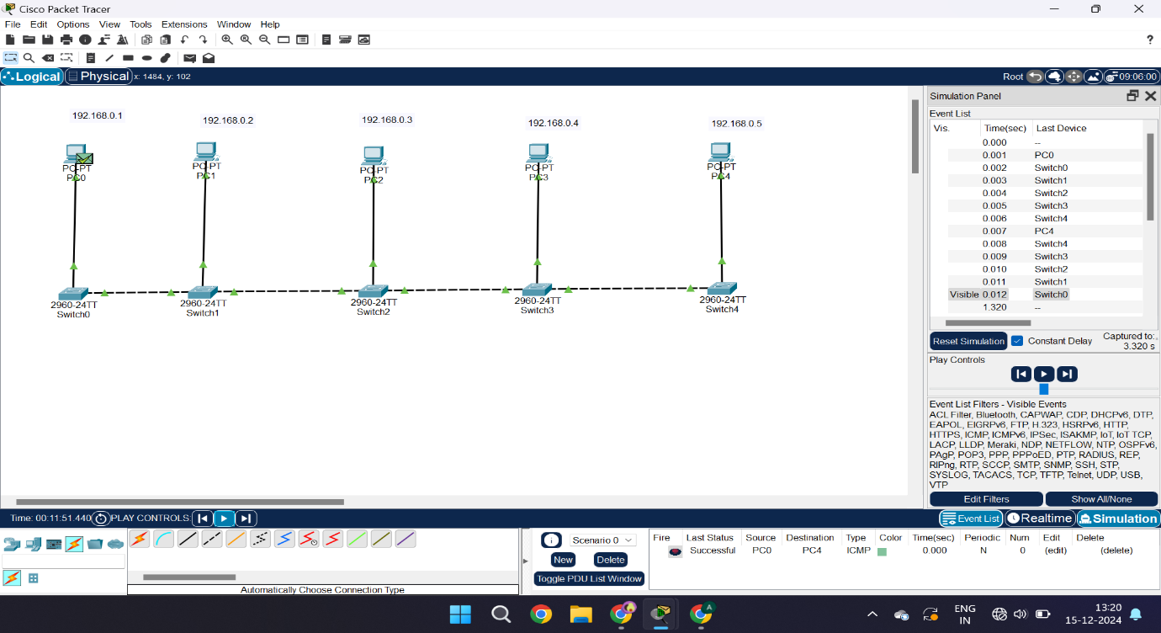**Fig-1.7: Acknowledgement received by the source.**

**2.RING TOPOLOGY:**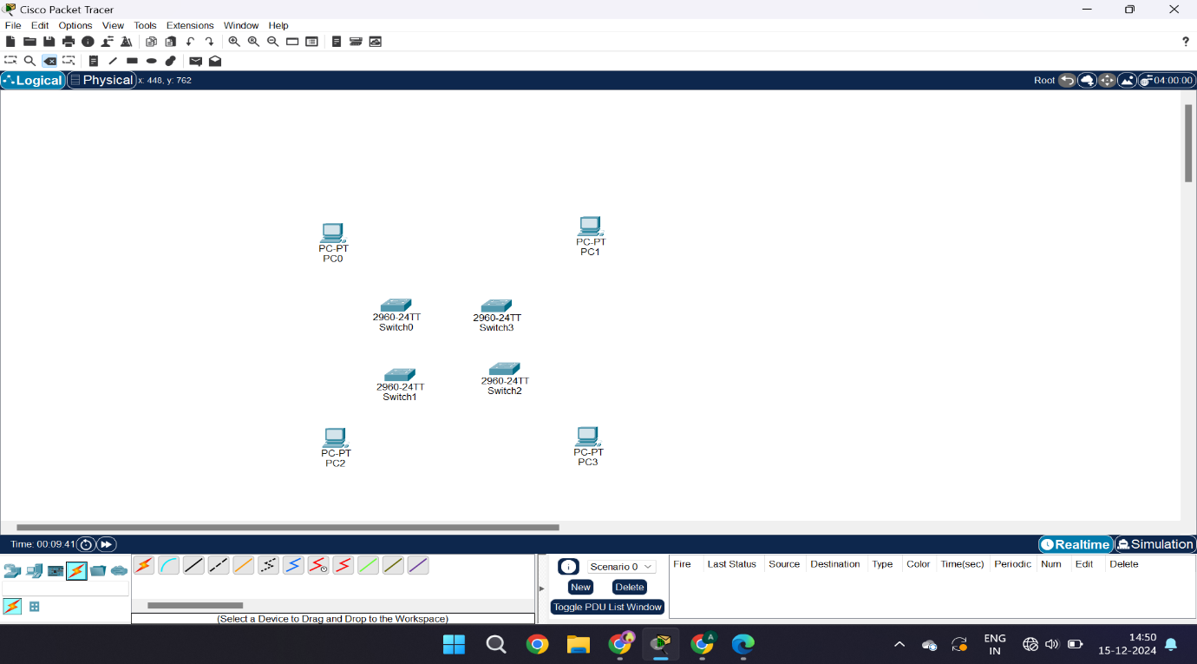

**Fig-2: Setting up PCs and Switches.**

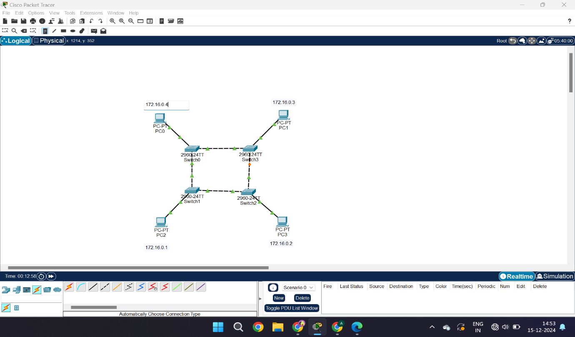**Fig-2.1: Connecting Switches and PCs. Giving IP address.**

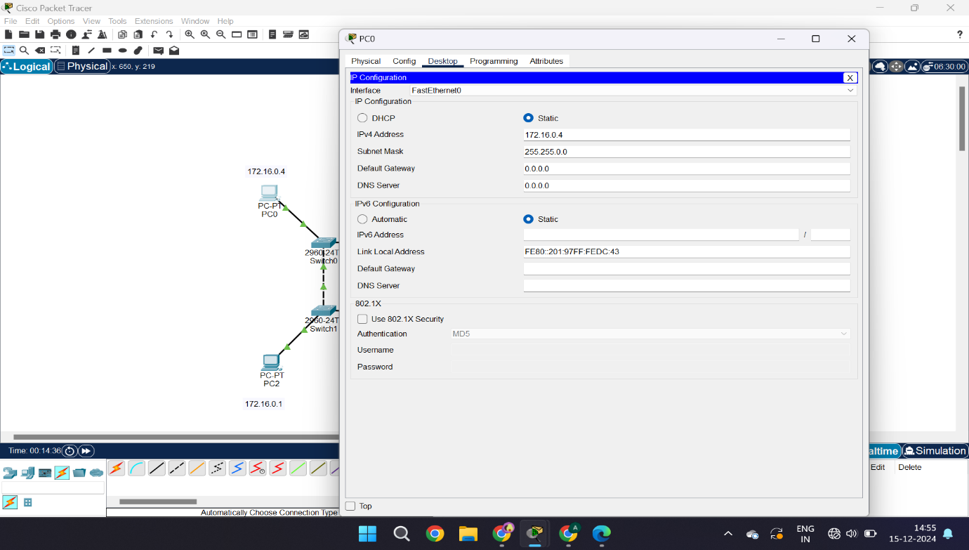**Fig-2.2: Assigning IPv4 Address to PCs.**

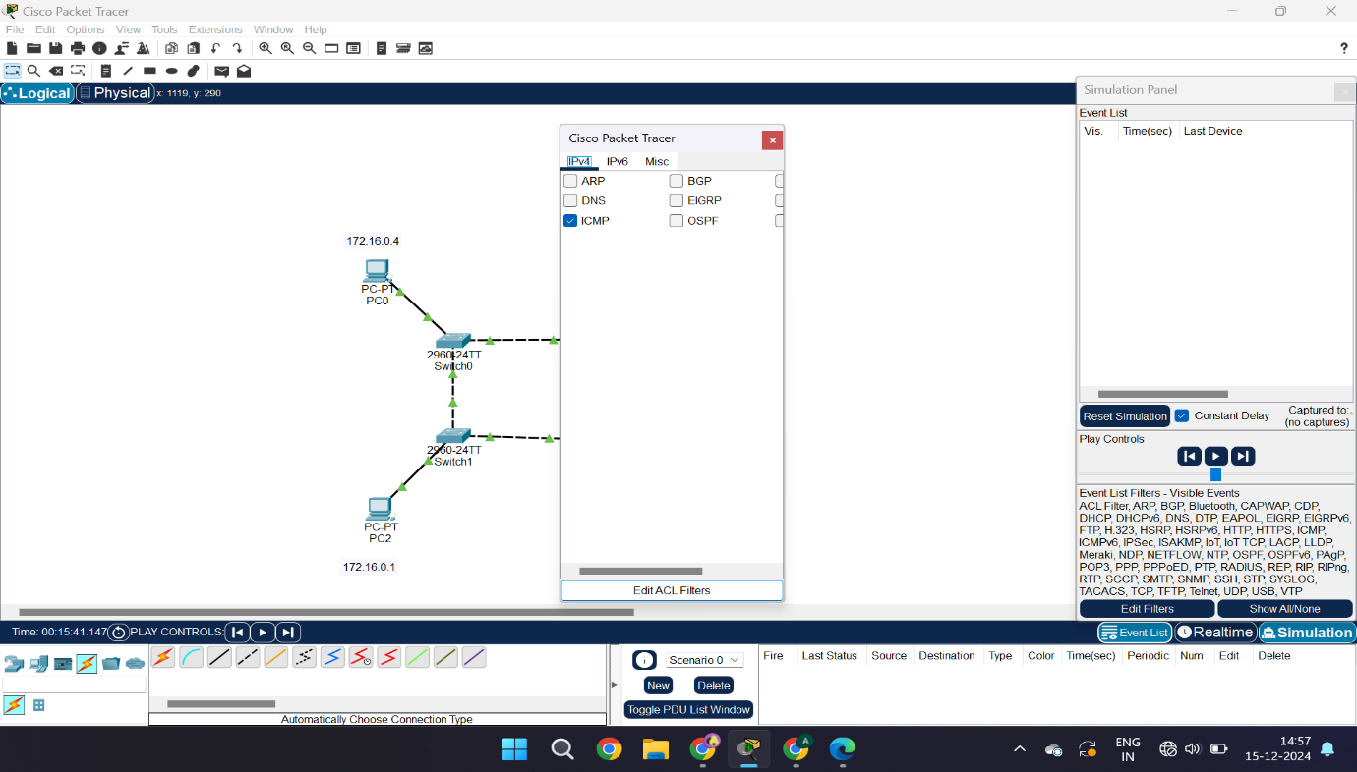

**Fig-2.3: Starting simulation and chose ICMP mode.**

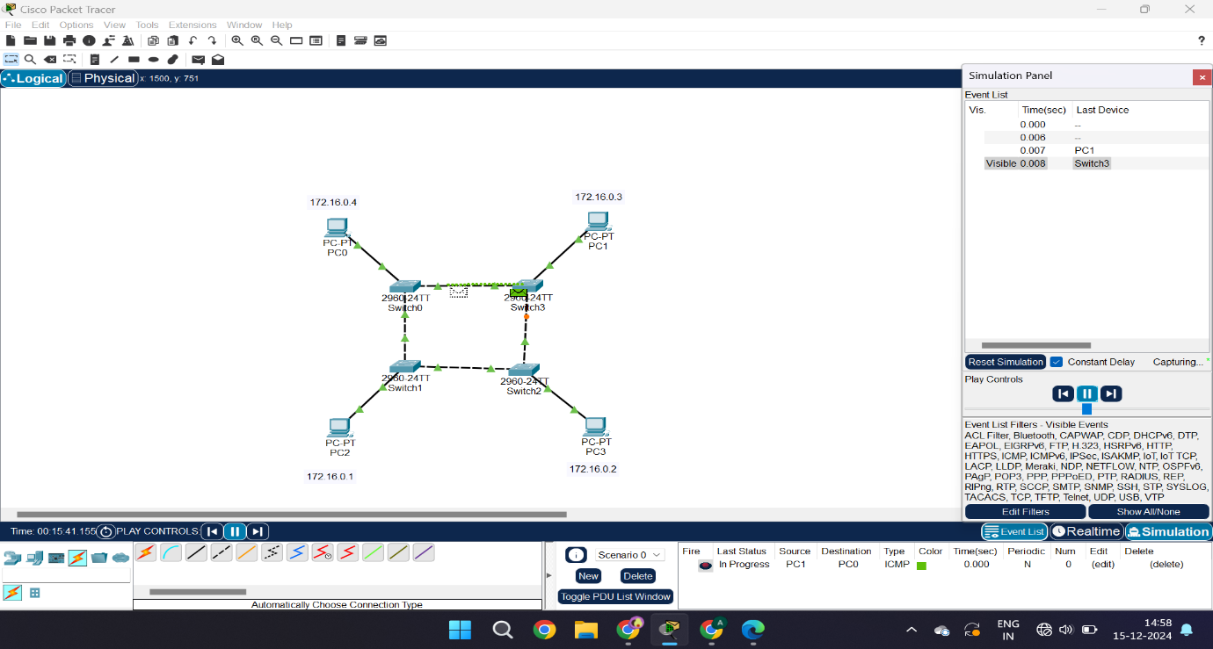

**Fig-2.4: Sending Packet from Source(PC3) to Destination(PC4).**

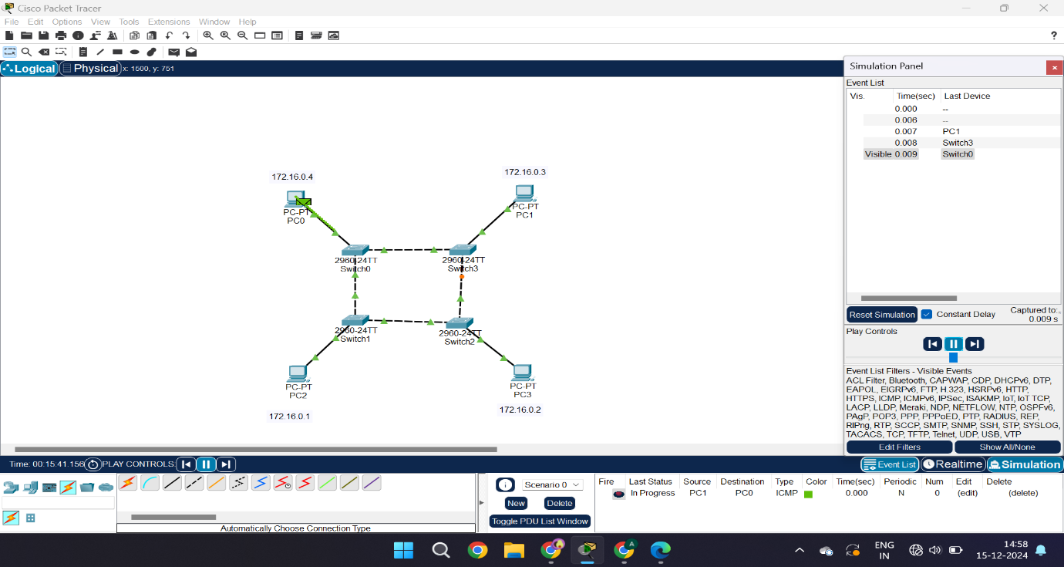**Fig-2.5: Packet received and sending acknowledgement to source(PC3).**

**3. STAR TOPOLOGY:**

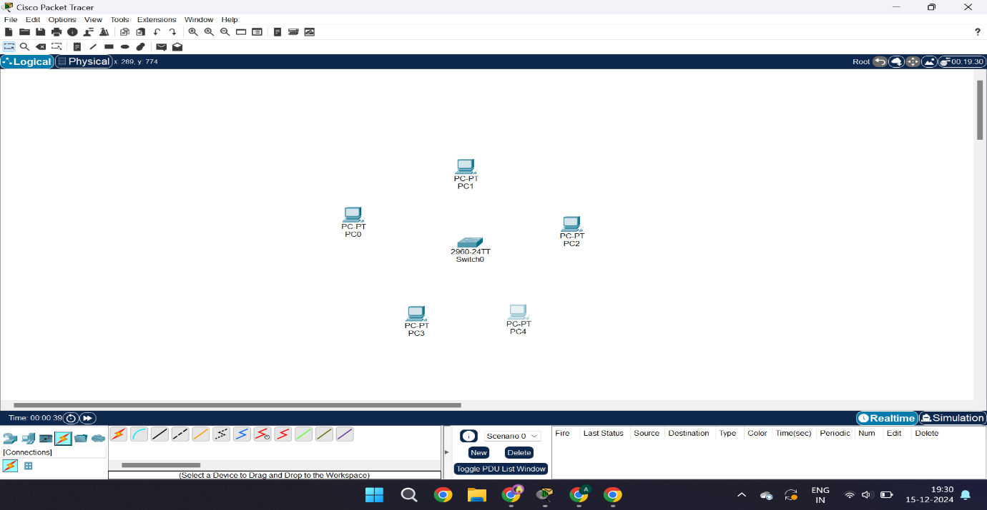

**Fig-3: Setting up PCs and a single Switch.**

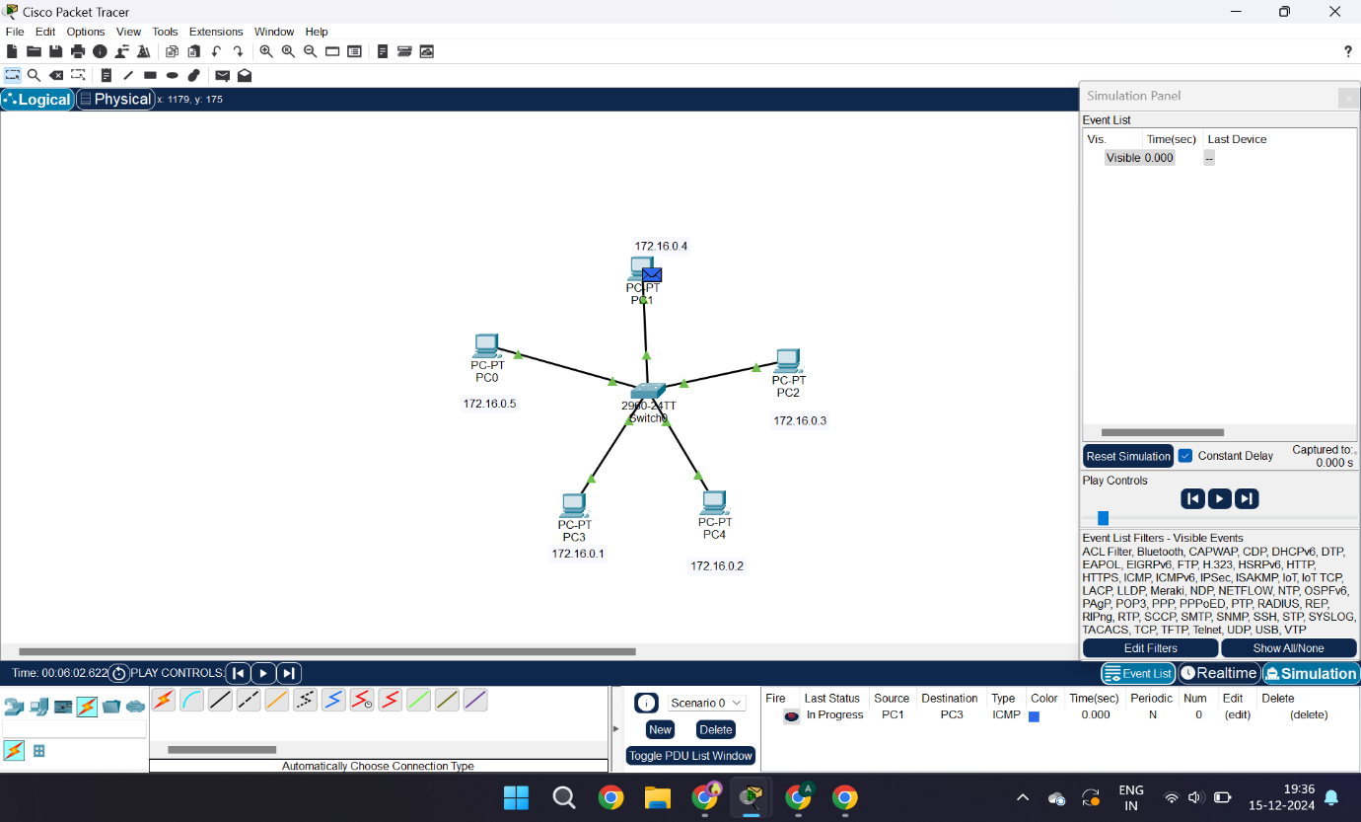

**Fig-3.1: Giving connections, labeling IP address and starting simulation from PC4 to PC1.**

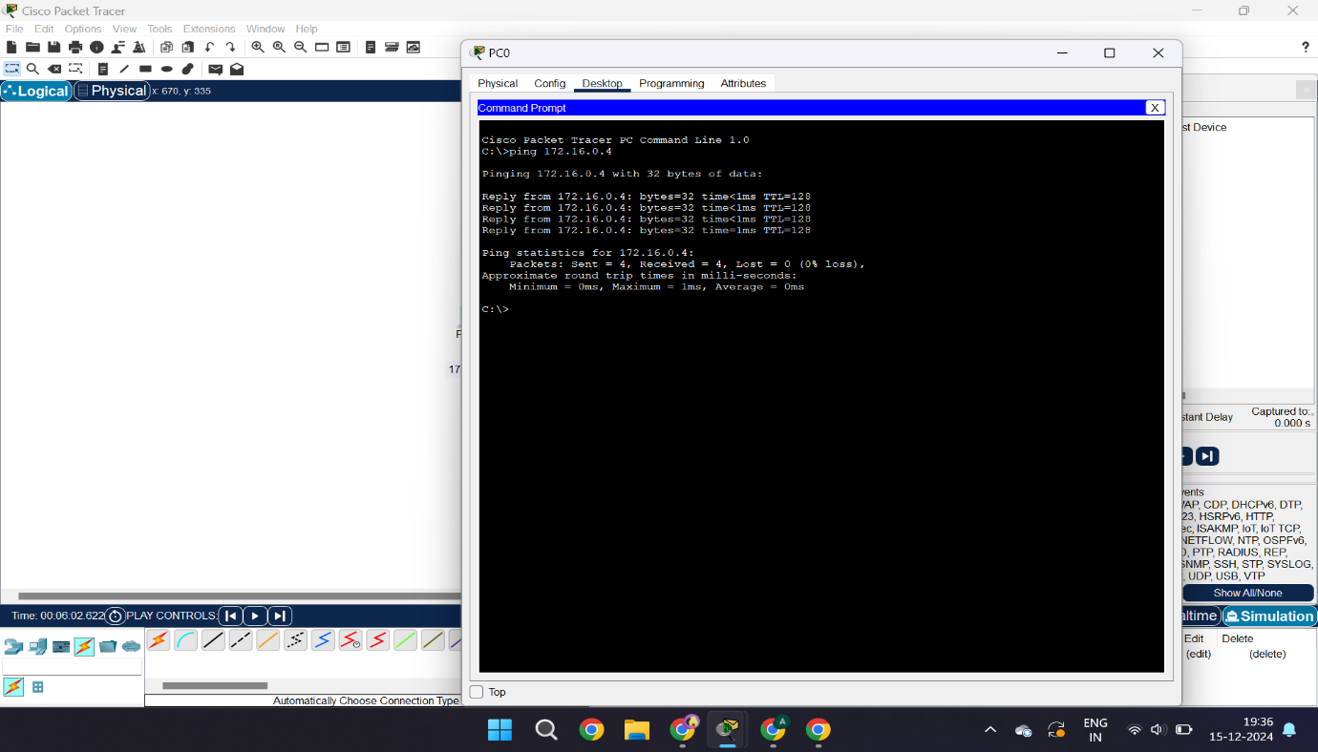**Fig-3.2: Ping the PC4 using command prompt.**

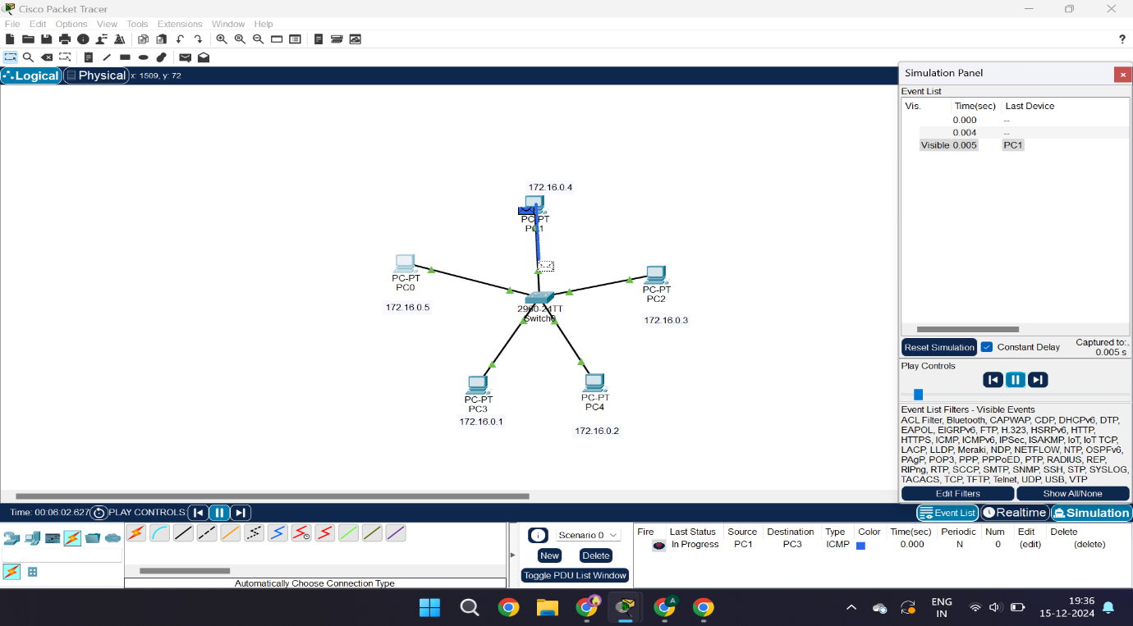**Fig-3.3: Sending packet from PC4(Source) to PC1(Destination).**

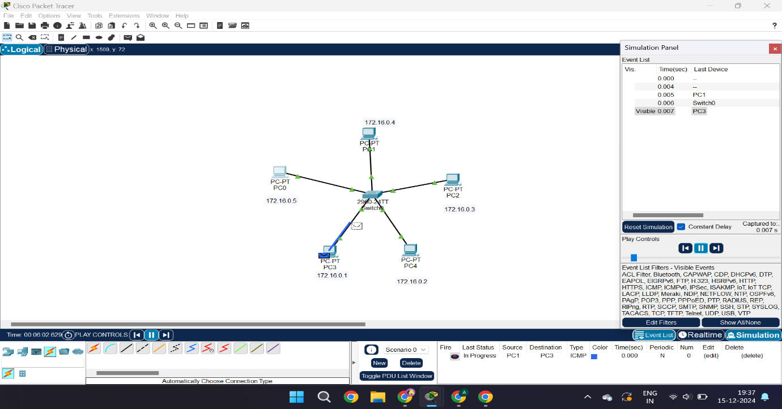

**Fig-3.4: Packet reached destination, acknowledgement sent.**

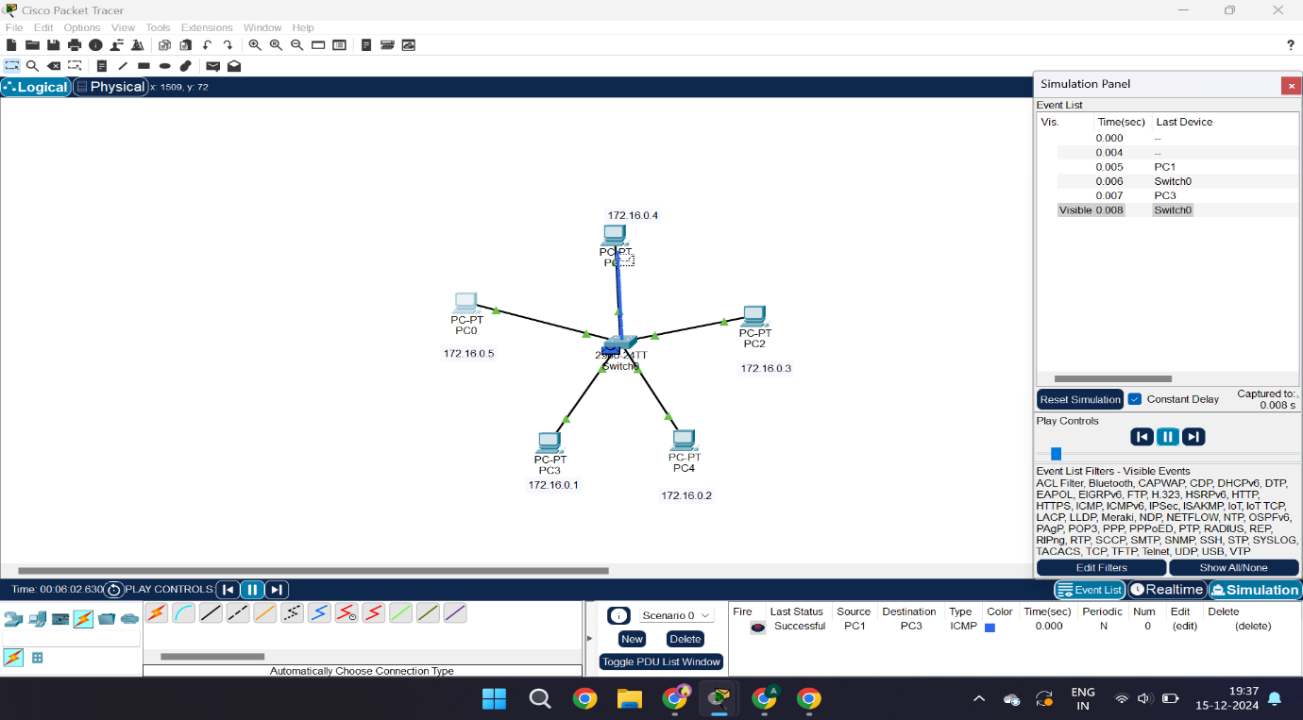**Fig-3.5: acknowledgement received by the source and sent to all PCs.**

**Real-World Applications and Future Scope**

1. **Bus Topology:**
   * Still used in legacy systems and small, low-traffic networks like small office or home environments.
   * Best suited for environments where cost constraints outweigh performance considerations.
2. **Ring Topology:**
   * Commonly implemented in fiber-optic networks and environments requiring predictable, collision-free communication, such as industrial networks and metropolitan area networks (MANs).
   * Dual-ring configurations enhance reliability, making it useful for mission-critical operations.
3. **Star Topology:**
   * Dominates modern LANs, office networks, and residential networks due to its robustness, scalability, and performance efficiency.
   * Widely used with technologies like Ethernet and Wi-Fi networks.

**Future Scope**:

* As networks evolve, hybrid topologies combining the strengths of bus, ring, and star topologies are gaining traction.
* Simulations with advanced protocols (e.g., OSPF, RIP) and technologies like **SDN (Software-Defined Networking)** can further optimize performance and scalability.
* Incorporating fault-tolerant techniques and redundancy into simulations can address limitations like single points of failure.

**CONCLUSION**

The project provides a strong foundation for understanding the design, implementation, and behavior of key network topologies—Bus, Ring, and Star—through hands-on simulations. By analyzing their performance, strengths, and limitations, the study equips network engineers, students, and researchers with the knowledge to design efficient, scalable, and resilient networks. These insights will contribute to solving real-world networking challenges and paving the way for innovative advancements in network design and optimization.

**BIBILOGRAPHY**

1. [GeeksforGeeks](https://www.googleadservices.com/pagead/aclk?sa=L&ai=DChcSEwjdm9a5gq-KAxVxEHsHHdlUF2gYABAAGgJ0bQ&ae=2&aspm=1&co=1&ase=5&gclid=CjwKCAiA34S7BhAtEiwACZzv4XVSNHt33OWG2MwaxLG8cXi7KdOXL4kPUbwXAM6lh-eMD4HNVdGXihoCRJUQAvD_BwE&ohost=www.google.com&cid=CAESVeD2ZosTTDxMI9YGLxQCmf7_YXzmqJTe2SLv-WEHwwL_RKucGh7xhYCS6Ug1jtAafoUhkOG7lJREJKQcIaSzCnC9TWsCCA_KnUyFjmFJ5FPrYtUDD3A&sig=AOD64_1DCy22JuZxfMGY1HIrjX-3DHOpug&q&adurl&ved=2ahUKEwj2tdG5gq-KAxUXQPUHHbhnHegQ0Qx6BAgKEAE)
2. Wikipedia
3. Uninets
4. Cisco. "Packet Tracer Tool Documentation." Cisco Systems.
5. IEEE and ACM Journals on Computer Networking.